Module – I: Introduction to Computers
Ques: | What do you mean by Programming?
Programming is a process of creating some set of instructions that tells a computer to perform some specific tasks or operations. Programming can be performed using some variety of different programming languages such as C, C++, Java, C# etc.
Ques: | What do you mean by Language?
Language is the medium of communication to share ideas, opinion with each other.
Ques: | What do you mean by Programming Language?
Programming language is the medium of communication between you (a person) and a computer system. Some properties are –
- A programming language is a set of rules that provides a way of telling a computer what operations to perform.
- A programming language is a set of rules for communicating an algorithm.
- It provides a linguistic framework for describing computations
Ques: | Why should we learn programming language?
There are some great reasons, for which we should learn code –
- For increasing Logical Ability
- Coding Teaches us - How to Approach Problem – Solving
- Out of the box Thinking – enhances Creativity
- Improved Critical-thinking skills
- Programming keeps our mind active and busy… for Lifetime
- Being Able to Turn an Idea into an App
- Automate Daily Tasks and Save Time
Ques: | Discuss about some levels of Computer Programming Language
There are basically two types of computer programming languages, they are –
- Low Level Programming Languages - Low-level languages are designed to operate and handle the entire hardware and instructions set architecture of a computer directly.
e.g., Machine Language and Assembly Language are popular examples of low-level languages.

- High Level Programming Languages - These are the machine independent programming languages, which are easy to write, read, edit and understand.
e.g., The languages like Java, .Net (C#), C++, C etc. are the example of high-level languages.
Ques: | What are the generations of Computer Programming Language?
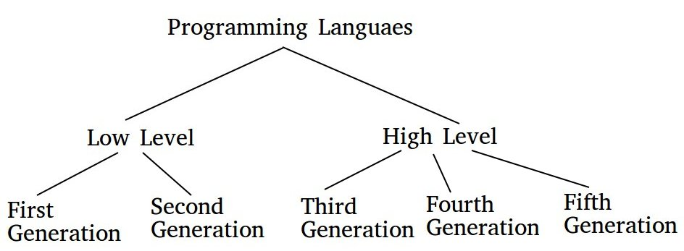

Ques: | What are the types of Computer Programming Language?
We can classify our programming languages in 4 sections, based on their principal programming paradigms, they are –
- Procedural Programming Language
- Object – Oriented Programming language
- Functional Programming Language
- Scripting Programming Language
- Logic Programming Language
Ques: | What is Translators? What are the different types of Translators.
- A program written in high-level language, is called as Source Code. To convert source code into machine code, translators are needed. A translator takes a program written in source language as input and converts it into a program in target language as output. It also detects and reports the error during translation.
- Different types of translators are –
- Compiler
- Interpreter
- Assembler
Ques: | What do you mean by Compiler?
Compiler is a translator which is used to convert programs in high – level language to low - level language. It translates the entire program and also reports the errors in source program encountered during the translation.
Ques: | What do you mean by Interpreter?
Interpreter is a translator which is used to convert programs in high – level language to low – level language. Interpreter translates line by line and reports the error once it encountered during the translation process. It gives better diagnostics than a compiler.
Ques: | What do you mean Assembler?
Assembler is a translator which is used to translate the assembly language code into machine language code.
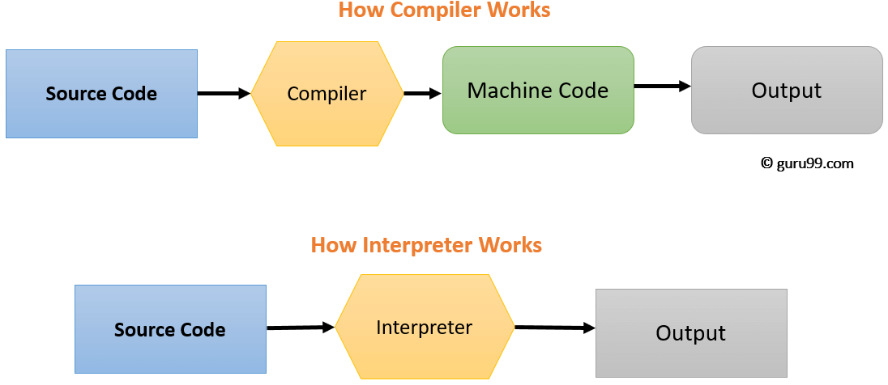
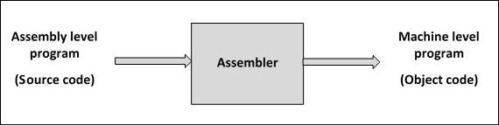

Ques: | What is C language?
C is a mid-level and procedural programming language.
Ques: | What do mean by Procedural Programming Language?
The Procedural programming language is also known as the structured programming language, is a technique in which large programs are broken down into smaller modules, and each module uses structured code.
Ques: | Who is the founder of C Language?
Dennis Ritchie
Ques: | Why is C known as a mother language?
C is known as a mother language because most of the compilers and interpreters are written in C Language.
Ques: | What are the features of the C language?
There are many features in C Language such as –
- Simple
- Machine Independent or Portable
- Structure Programming Language
- Mid – Level Programming Language
- Fast Speed
- Memory Management (Dynamic Memory Allocation)
- Rich Library
- Uses of Pointer
- Uses of Recursion
- Extensible (Can easily adopt new features)
Ques: | What do you mean by Flowchart?
A flowchart is a type of diagram that represents a workflow or process. The flowchart shows the steps as boxes of various kinds, and their order by connecting the boxes with arrows.
Ques: | What do you mean by Algorithm?
An algorithm is a step by step method of solving a problem. It is commonly used for data processing, calculation and other related computer and mathematical operations.
Ques: | What are the steps to solve the problem in a computer system?
- Problem must be analyzed thoroughly.
- Solution method is broken down into a sequence of small tasks.
- Based on this analysis, an algorithm must be prepared to solve the problem.
- The algorithm is expressed in a precise notation. This notation is known as “Computer Program”.
- The Computer program is fed to the computer.
- The instruction in the program executes one after another and outputs the expected result.

Ques: | What do you mean by Pseudo Code?
“Pseudo” means imitation of false and “code” refers to the instruction written in the programming language. Pseudo code is programming analysis tool that is used for planning program logic.
Ques: | What do you mean by header files? What are the header files?
Header file is a file that contains function declaration and macro definition for C in-built library functions. Header files are files with extension .h, the two common header files are stdio.h and conio.h
Ques: | What do you mean by Token in C language?
C tokens are the basic buildings blocks in C language which are constructed together to write a C program. Each and every smallest individual unit in a C program are known as C token.
Ques: | What are the types of C Tokens?
There are six types of tokens, such as –
- Identifiers
- Variables
- Keywords
- Constants
- Operators
- Punctuators
Ques: | What do you mean by Constant in C language? What is the difference between Constant & Literal?
Constants refer to fixed values. They are also called as literals. C Constants are also like normal variables. But, only difference is, constant values can’t be modified by the program once they are defined. Constants may be belonging to any of the data type.
Ques: | How many constants are there in C Language?
There are four basic types of constants in C. Those are –
1.Integer Constants
2.Floating-Point Constants
3.Character Constants
4.String Constants
Ques: | What do you mean by Variable?
A variable is a way of referring to a memory location used in a computer program. The format for declaring a variable in C.
type data variable name [= initial value];
Ques: | What are the different types of Variable in c?
There are three types of variables in C –
- Local Variable
- Global Variable
- Environment Variable

Ques: | What is the difference between Variable Declaration & Variable Definition?
- Variable declaration tells the compiler about data type and size of the variable. Whereas, variable definition allocates memory to the variable

- Variable can be declared many times in a program. But, definition can happen only one time for a variable in a program.
- Variable declaration is for assignment of properties and identification to a variable. Whereas, variable definition is for assignments of storage space to a variable
Ques: | What do you mean by Datatype?
A datatype specifies the type of data that a variable can store values such as Integer, Floating Point Number, Character etc.
Ques: | How many types of Datatype are there?
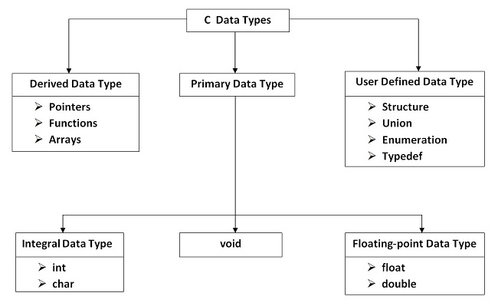
Ques: | Specify the ranges of Datatypes.
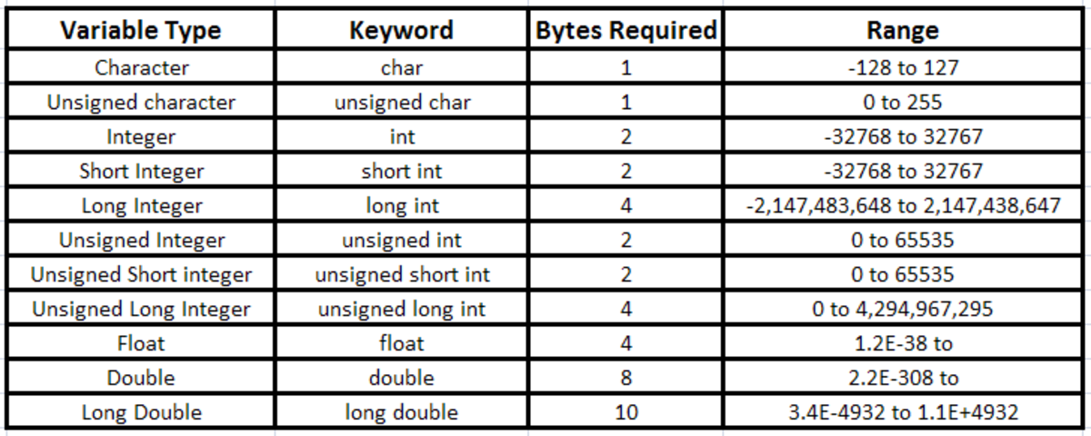

Ques: | What do you mean by Format Specifier?
It is a string used in the formatted input and output functions. The basic format specifiers are –
%d | Integer Format Specifier
%f | Floating Point Number Format Specifier
%c | Character Format Specifier
%s | String Format Specifier
%u | Unsigned Integer Format Specifier
%ld | Long Int Format Specifier

Ques: | Specify the Minimum Field Width Specifier of Format Specifier.
- %8d – It occupies a minimum no., 8 spaces on the screen.
- %-8d – Same value but it is left aligned.
- %08d – It means the empty space, is filled with zeros.
- %.2f – (Specify Precision) Dot operator shows the precision (no. of decimals)
Ques: | How many ways to define Constants?
There are 2 ways to define constants in C Programming –
- const Keyword
- #define preprocessor
Ques: | What is the differences between = and == symbol?
The = symbol is often used to represent the mathematical operator. It is used to assign a value to a given variable. On the other hand, the == symbol is known as equal to or equivalent to, it is a relational operator that is used to compare two values.

Module – II: Conditional Control Statements
Ques: | What do you mean by Operator?
An operator is a symbol that tells the compiler to perform specific mathematical or logical manipulations. C language is rich in built-in operators and provides the following types of operators -
- Arithmetic Operators | - Bitwise Operators
- Relational Operators | - Assignment Operators
- Logical Operators | - Misc. Operators

Ques: | Write a short note on type casting.
Casting is used to explicitly convert the value of one type to another. The result of cast is a new reference or a value.
Ques: | Explain sizeof() with example?
It returns the size of a variable. For example – if a is an integer variable, sizeof(a), where a is integer, will return 2.
Ques: | What do you mean by Operator Precedence?
Operator precedence determines the grouping of terms in an expression. This affects how an expression is evaluated. Certain operators have higher precedence than others.

Ques: | What is the output of printf("%d")?
When we write printf("%d",x); this means compiler will print the value of x. But as here, there is nothing after %d so compiler will show in output window garbage value.
Ques: | What is meant by Enumerated data type.
Enumerated data is a user defined data type in C language. Enumerated data type variables can only assume values which have been previously declared.
Example - enum month { jan = 1, feb, mar, apr, may, jun, jul, aug, sep, oct, nov, dec };
Ques: | Difference between Local and Global variable in C.
- Local variable is declared inside a function whereas Global variable is declared outside the function.
- Local variables are created when the function has started execution and is lost when the function terminates, on the other hand, Global variable is created as execution starts and is lost when the program ends.
Ques: | What is the difference between ++a and a++?
- ++a means do the increment before the operation (prefix)
- a++ means do the increment after the operation (postfix)
example – int a = 10;
int x = a++;
int y = ++a;
Ques: | Mention the various Decisions making statement available in C.
Statement | Description
if statement | An if statement consists of a boolean expression followed by one or more statements.
if...else statement | An if statement can be followed by an optional else statement, which executes when the boolean expression is false.
nested if statements | We can use one if or else if statement inside another if or else if  statement(s).
switch statement | A switch statement allows a variable to be tested for equality against a list of values.
nested switch statements | You can use one switch statement inside another switch statement(s).

Ques: | What do you meant by conditional or ternary operator?
It is actually the if condition that we use in C language decision making, but using conditional operator, we turn the if condition statement into a short and simple operator.
?: If Condition is true ? Then value X : Otherwise value Y
Ques: | What are the types of I/O statements available in C?
There are two types of I/O statements available in C -
- Formatted I/O Statements
- Unformatted I/O Statements

Ques: | State the example of delimiters in C.
: | Colon
; | Semicolon
() | Parenthesis
[] | Square Brackets
{} | Curly Braces
# | Hash
, | Comma

Ques: | What do you mean by Error?
Errors are the problems or the faults that occur in the program, which makes the behavior of the program abnormal, and experienced developers can also make these faults. Programming errors are also known as the bugs or faults, and the process of removing these bugs is known as debugging.
Ques: | How many types of Errors in C Language?
There are mainly five types of errors exist in C programming –
- Syntax Error
- Run-Time Error
- Linker Error
- Logical Error
- Semantic Error
Ques: | State the differences between Compile Time Error vs. Run Time Error
Compile Time Error | Run Time Error
The compile-time errors are the errors which are produced at the compile-time, and they are detected by the compiler. | The runtime errors are the errors which are not generated by the compiler and produce an unpredictable result at the execution time.
In this case, the compiler prevents the code from execution if it detects an error in the program. | In this case, the compiler does not detect the error, so it cannot prevent the code from the execution.
It contains the syntax and semantic errors such as missing semicolon at the end of the statement. | It contains the errors such as division by zero, determining the square root of a negative number.

Ques: | What do you mean by Switch Case Statement?
The switch statement in C is an alternate to if-else-if ladder statement which allows us to execute multiple operations for the different possible values of a single variable called switch variable.
Ques: | What do you mean by Fall Through?
In C, 'fall-through' occurs when the flow of execution in a switch statement reaches a case label other than by jumping there from the switch header, passing a point where one would normally expect to find a break.

Ques: | What are the differences between Break Statement & Continue Statement?
Break Statement –
- A break statement is used to terminated the execution of a statement block. The next statement which follows this statement block will be executed.
- The keyword is break.
- When a break statement is executed in a loop, the repetition of the loop will be terminated.
Continue Statement –
- A continue statement is used to transfer the control to the beginning of a statement block.
- The keyword is continue.
- When a continue statement is executed in a loop, the execution is transferred to the beginning of the loop.
Ques: | What is the utility of Exit() function?
- An exit() function is used to terminate the execution of a C Program permanently.
- It is a built-in function and is called with necessary argument as – exit(0)
Ques: | What do you mean by Loop?
In computer science, a loop is a programming structure that repeats a sequence of instructions until a specific condition is met.
Ques: | Segregate the Loop categorically in details.
Loop is divided into two main categories –
- Entry Controlled Loop
- Exit Controlled Loop
Example of Entry Controlled Loop are – for, while
Example of Exit Controlled Loop is – do - while
Ques: | What is the difference between if and while statement?
IF Statement | WHILE Statement
- It is a conditional statement | - It is a loop control statement
- If the condition is true, it executes some statements | - Executes the statements within the while block if the condition is true.
- If the condition is false then it stops the execution the statements. | - If the condition is false the control is transferred to the next statement of the loop.

Ques: | What is the difference between while(0) and while(1)?
while(1) is an infinite loop, which will run till a break statement occurs. Similarly, while(2), while(3), …, while(255) etc. will give infinite loops only.

Whereas, while(0) does the exact opposite of this. When while(0) is used, it means the conditions will always be false.

Thus, as a result, the program will never get executed.

Ques: | What do you mean by infinite loop?
An infinite loop is a looping construct that does not terminate the loop and executes the loop forever. It is also called an indefinite loop or an endless loop. It either produces a continuous output or no output.
Example –
for(; ;)
{
// body of the for loop.
}
Ques: | Define goto Statement.
- The goto statement is known as jump statement in C.
- goto is used to transfer the program control to a predefined label.
- The goto statement can be used to repeat some part of the code for a particular condition.
- It can also be used to break the multiple loops which can't be done by using a single break statement.
Ques: | What do you mean by User defined Function?
A user-defined function (UDF) is a function provided by the user of a program or environment, in a context where the usual assumption is that functions are built into the program or environment.
Ques: | How many types of user defined functions are there in C Language?
There are 4 types of user defined functions in C Language –
- Without return type, without parameters
- Without return type, with parameters
- With return type, without parameters
- With return type, with parameters
Ques: | What do you mean by return statement?
A return statement ends the execution of a function, and returns control to the calling function. Execution resumes in the calling function at the point immediately following the call. A return statement can return a value to the calling function
Ques: | What does static variable mean?
A return statement ends the execution of a function, and returns control to the calling function. Execution resumes in the calling function at the point immediately following the call. A return statement can return a value to the calling function
Ques: | What do you mean by recursion?
- When a function is called, by itself then the function is called Recursive Function and process is called Recursion.
- Recursion is the process where a function, is called by itself.

Ques: | How many types of Recursion are there?
There are 5 types of Recursion –
- Linear Recursion
- Binary Recursion
- Tail Recursion
- Mutual Recursion
- Nested Recursion
Ques: | What do you mean by Storage Class?
A Storage Class defines the scope i.e., visibility and life span of variables and functions in a C Program. There are four types of Storage Class in C Programming –
- Auto
- Register
- Static
- Extern
Ques: | Specify the details of Storage Class
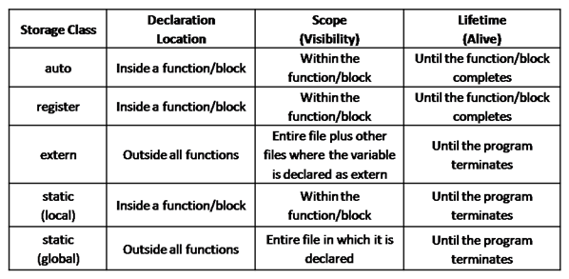
Ques: | Define advantages of Function
There are several advantages of function –
- Increase Readability
- Decrease LOC (Line of Code)
- Minimize the effort of testing, debugging and maintenance
- Increasing reusability
- Helps in Top – Down modular programming
Ques: | Sections of User Defined Functions -
There are mainly three sections of UDF –
- Declaration
- Definition
- Calling

Ques: | Difference between Formal Parameters and Actual Parameters.
- Formal Parameter — the identifier used in a method to stand for the value that is passed into the method by a caller.
- Actual Parameter — the actual value that is passed into the method by a caller.
Ques: | State the difference between Parameter and Argument.
- Parameter – It is a variable defined by a method that receives a value when the method is called.
- Argument – An argument is a value that is passed to a method when it is invoked.
Ques: | What do you mean by Function Prototype?
The function prototype depends on the following –
- No. of input Types
- No. of outputs which are to be returned
Ques: | Define – Call by Value
- In this method, the value of actual parameter is copied into the formal parameters.
- In this method, we can’t modify the value of the actual parameter by formal parameters.
- Different memory is allocated for actual parameters and formal parameters.
Ques: | Define – Call by Reference
- In this method, the address of variable is passed into the function through the actual parameters.
- The value of the actual parameters can be changed.
- Similar types of memory can be allocated for both actual & formal parameters.

Module – III: Pre-processors and Arrays
Ques: | What do you mean by Array?
- An array is defined as a collection of homogeneous data elements, stored in contiguous memory locations.
- Array is the derived datatype in C Programing
- Array is one of the simplest data structure where each data element can be accessed by using its index no.
Ques: | What are advantages of Array?
- Code Optimization
- Easy of Traversing
- Easy of Searching/Sorting
- Random Access
Ques: | What are disadvantages of Array?
- Fixed Size
- Static Allocation
- Contiguous Memory Allocation

Ques: | What are the differences between Linear Search and Binary Search?
Linear Search –
- The elements are in random in order
- Access speed is slow
- Single and Multi-dimensional array is sorted used
Binary Search –
- The elements are in sorted order
- Access speed is faster
- Only single dimensional array is sorted used

Module – IV: Pointers
Ques: | What do you mean by Pointer?
- It is a variable which is stored the address of another variable
- This variable can be the type of int, char, array, function or any other pointer.
- Size of the pointer depends on its architecture 32-bit architecture, the size of a pointer is 2 bytes.
Ques: | What do you mean by indirection Pointer?
The pointer of C language can be declared using * (asterisk sign) symbol. It is also known as Indirection Pointer, used to deference a pointer.
int *a;
Ques: | What are the advantages of a Pointer?
- Pointer reduces the code and improves the performance.
- Pointer return multiple values from a function using the pointer.
- It makes able to access any memory location in the computer’s memory.
Ques: | What do you mean by NULL Pointer?
A pointer that is not assigned to any value but NULL, is known as the NULL Pointer. If we don’t specify any address to the pointer at the time of declaration, we can assign NULL value.
int *p = NULL;
Ques: | What do you mean by Function Pointer?
The function pointer is the pointer which access, the address of a function.
Ques: | What do you mean by Volatile variable?
Volatile variables are those variables which alters, the default way of the program. The variable which do not change which compiling but are changeable during execution.
Ques: | What do you mean by Constant Pointer?
- Constant Pointers cannot be modified.
- Modification in integers to which it points, is allowed.
- Modification made in pointer, is not allowed.
int num = 20;
int *const ptr = &num;

Ques: | What do you mean by Character Array?
String is a sequence of characters that is treated as a single data item and terminated by null character '\0'. A string is actually one-dimensional array of characters in C language.
Ques: | What is the difference between scanf() and gets() function?
In scanf() when there is a blank was typed, the scanf() assumes that it is an end. gets() assumes the enter key as end. That is gets() gets a new line (\n) terminated string of characters from the keyboard and replaces the ‘\n’ with ‘\0’.
Ques: | Define - String
The group of characters, digit and symbols enclosed within quotes is called as Stirng (or) character Arrays. Strings are always terminated with ‘\0’ (NULL) character. The compiler automatically adds ‘\0’ at the end of the strings.
char name[] = {‘C’,’O’,’L’,’L’,’E’,’G’,’E’,’E’,’\0’};
Ques: | Mention the various String Manipulation Functions in C.
- strcpy(s1, s2) - Copies string s2 into string s1.
- strcat(s1, s2) - Concatenates string s2 onto the end of string s1.
- strlen(s1) - Returns the length of string s1.
- strcmp(s1, s2) - Returns 0 if s1 and s2 are the same; less than 0 if s1<s2;
greater than 0 if s1>s2.
- strchr(s1, ch) - Returns a pointer to the first occurrence of character ch in
string s1.
- strstr(s1, s2) - Returns a pointer to the first occurrence of string s2 in string s1.
Ques: | What is the use of “typedef”?
It is used to create a new data using the existing type.
typedef data type name;
Ques: | Can we specify variable field width in a scanf() format string? If possible how?
All field widths are variable with scanf(). We can specify a maximum field width for a given field by placing an integer value between the ‘%’ and the field type specifier. Such a specifier will still accept a narrower field width.
Ques: | What is the difference between String and Array?
String is a sequence of characters ending with NULL. It can be treated as a one dimensional array of characters terminated by a NULL character.
Ques: | Are the expressions arr and &arr same for an array of integers?
Yes, for array of integers they are same.
Ques: | Difference between array and pointer?
Array | Pointer
Array allocates space automatically | Explicitly assigned to point to an allocated space.
It cannot be resized | It can be sized using realloc()
It cannot be reassigned | Pointer can be reassigned.
sizeof (arrayname) gives the number of bytes occupied by the array. | sizeof (p) returns the number of bytes used to store the pointer variable p.

Ques: | Difference between a array name and a pointer variable?
A pointer variable is a variable where as an array name is a fixed address and is not a variable. A pointer variable must be initialized but an array name cannot be initialized. An array name being a constant value , ++ and — operators cannot be applied to it.
Ques: | Are the expressions *ptr ++ and ++ *ptr same?
No, *ptr ++ increments pointer and not the value pointed by it. Whereas ++ *ptr increments the value being pointed to by ptr.
Ques: | Difference between function pointer and pointer to function?
Both are synonymous – both describes an object that can hold address of a function.
Ques: | What do you mean by Dynamic Memory Allocation?
- Memory is allocated in Run Time
- Memory can be increased during the program execution.
- Used in Linked List
Ques: | What do you mean by Static Memory Allocation?
- Memory is allocated in Compile Time
- Memory can not be increased during the program execution.
- Used in Array
Ques: | What do you mean by malloc()?
- malloc() function allocates memory blocks in bytes.
- malloc() returns a pointer to the first block of the memory.
- Type of the pointer is void
- If the malloc() fails, it returns NULL
- Under Turbo C compiler – it is available under the header files – alloc.h or stdlib.h
- Under Unix compiler – it is available under the header file – malloc.h
ptr = (int*) malloc (n * sizeof(int));
Ques: | What do you mean by calloc()?
- It is similarly like malloc function except malloc() allocates only one memory block whereas calloc() allocates multiple memory blocks.
- It requires two arguments at a time.
- Memory allocated by malloc() function contains garbage values, whereas calloc() function contains all zeros.
- Under Turbo C compiler – it is available under the header files – alloc.h or stdlib.h
- Under Unix compiler – it is available under the header file – calloc.h
ptr = (int*) calloc (n,byte_size);
Ques: | What do you mean by realloc()?
It memory is not sufficient for malloc() or calloc(), then we can reallocate the memory by realloc() function. It can change the memory size.
ptr = realloc(ptr, new_size);
Ques: | What do you mean by free()?
“free” method in C is used to dynamically de-allocate the memory.
free(ptr);

Module – V: Structures and File
Ques: | What do you mean by Structure?
- Structure allocates storage space for all its member separately.
- Structure occupies higher memory space (that Union).
- We can access all members of structure at a time.
- All members may be initialized.
Ques: | What do you mean by Union?
- Union allocates one common storage space for all its members accordingly.
- Union occupies lower memory space over structure.
- We can access only one member of union at a time.
- Only one member may be initialized.
Ques: | State the difference between Array and Structure.
The chief distinctions between Array and Structure are –
- All the elements in an array are of same type – homogeneous but all the elements of a structure are different in type – heterogeneous.
- A component in an array is referred to by its position whereas each component of a structure has a unique name.
Ques: | What is Memory Leak in C?
A memory leak occurs when programmers create memory in a heap and forget to delete it. It decreases the efficiently of the performance of the system.
Ques: | What is Volatile Variable in C?
Volatile variables are those variables which alters the default way of the program. The variable which do not change while compiling but are changeable during execution.
Ques: | What do you mean Preprocessor Directives?
- The C Preprocessor is a microprocessor that is used by compiler to transform codes before compilation.
- It is also called preprocessor because it allows us to add macros.
- Preprocessors directives are executed before compilation.
- All preprocessor directives are started with a # (hash) symbol.
Example –
#include | #define | #undef | #ifdef | #pragma | #error
#else | #elif | #ifndef | #if | #endif

Ques: | How many Preprocessor Directives are there?
There are total 11 preprocessor directives in C Language.
Ques: | What do mean by Macro?
A macro is a segment of code, which is replaced by the value of macro. Macro is defined by #define directive.
Ques: | How many types of macro are there?
- Object like Macros
- Function like Macros

Ques: | What are the macro’s advantages and disadvantages?
- The advantage of macro is that it reduces the time taken for control transfer as in case of function.
- The disadvantage of it is here the entire code is substituted so the program becomes lengthy if a macro is called several times.
Ques: | Difference between linker and linkage?
Linker converts an object code into an executable code by linking together the necessary built in functions. The form and place of declaration where the variable is declared in a program determine the linkage of variable.
Ques: | What is the similarity between a Structure, Union and Enumeration?
All of them let the programmer to define new data type.
Ques: | What are the advantages of Preprocessor?
- A preprocessor involves the readability of program
- It facilitates easier modification
- It helps in writing portable programs
- It enables easier debugging
- It enables testing a part of program
- It helps in developing generalized program
Ques: | What are the facilities provided by Preprocessor?
- File inclusion
- Substitution facility
- Conditional compilation
Ques: | What is a File?
A file is a region of storage in hard disks or in auxiliary storage devices. It contains bytes of information. It is not a data type.
Ques: | What are the types of File?
Files are of two types -
- High Level files (stream oriented files): These files are accessed using library functions
- Low Level files (system oriented files): These files are accessed using system calls
Ques: | What is a Stream?
A stream is a source of data or destination of data that may be associated with a disk or other I/O device. The source stream provides data to a program and it is known as input stream. The destination stream receives the output from the program and is known as output stream.
Ques: | What is meant by File Opening?
The action of connecting a program to a file is called opening of a file. This requires creating an I/O stream before reading or writing the data.

Ques: | What is a File Pointer?
The pointer to a FILE data type is called as a stream pointer or a file pointer. A file pointer points to the block of information of the stream that had just been opened.
Ques: | What is a Random Access File?
A file can be accessed at random using fseek() function
fseek(fp, position, origin);
where fp file pointer position number of bytes offset from origin
and origin 0,1 or 2 denote the beginning ,current position or end of file respectively.
Ques: | Can main () be called recursively?
Yes, any function including main () can be called recursively.
Ques: | Is using exit() the same as using return?
No. The exit() function is used to exit our program and return control to the operating system. The return statement is used to return from a function and return control to the calling function. If we issue a return from the main() function, we are essentially returning control to the calling function, which is the operating system. In this case, the return statement and exit() function are similar.
Ques: | What is Indirection?
If we declare a variable, its name is a direct reference to its value. If we have a pointer to a variable, or any other object in memory, we have an indirect reference to its value.

============================================

